
AHDB Recommended Lists (RL) for cereals and oilseeds: Testing cabbage stem flea beetle variety resilience (2022–26)
This protocol was believed to comply with relevant agrochemical, environmental and other regulations at the time of writing but it is the responsibility of the contractor to ensure that it continues to comply. In the event of non-compliance the protocol should not be followed but the Field Trials Manager should be notified at once of how the protocol requirements would breach regulations.

Any deviation from this protocol other than under the circumstances described above may result in a breach of contract and should be agreed in advance.

While the Agriculture and Horticulture Development Board seeks to ensure that the information contained within this document is accurate at the time of printing, no warranty is given in respect thereof and, to the maximum extent permitted by law, the Agriculture and Horticulture Development Board accepts no liability for loss, damage or injury howsoever caused (including that caused by negligence) or suffered directly or indirectly in relation to information and opinions contained in or omitted from this document.

Reference herein to trade names and proprietary products without stating that they are protected does not imply that they may be regarded as unprotected and thus free for general use. No endorsement of named products is intended, nor is any criticism implied of other alternative, but unnamed, products.

AHDB Cereals & Oilseeds is a part of the Agriculture and Horticulture Development Board (AHDB).

Changes from previous version

No changes from previous version.

Contents
Each of the sections listed below can be used to navigate the document by left clicking the relevant section whilst pressing the Ctrl button at the same time.

Title Page 1
Contents 2
Changes from previous version 2
Testing Cabbage Stem Flea Beetle (CSFB) variety resilience 3
Aim 3
Assessments 3
Completion of records 6
Contact us 6

Testing Cabbage Stem Flea Beetle (CSFB) variety resilience

Aim
The aim of the protocol is to assess the percentage of plants with an intact main raceme (MR).

Assessments
If possible, score at two timings.

- the first at GS 3.7 (BBCH 57), just prior to flowering
- the second at GS 4.8-5.5 (BBCH 67-75) late flowering to mid pod set.

If it is only possible to score at one timing due to logistics etc., please score at the later timing GS 4.8-5.5.

Scoring should be done using the 1-9 scale as described below:

Table 2: CSFB assessment scores
Score | Comment
9 | No damage, 100% of plants with a MR*
8 | 10% of plants with no MR
7 | 25% of plants with no MR
6 | 50% of plants with no MR
5 | 75% of plants with no MR
4 | 100% of plants with no MR, side branches extended flowering
3 | 100% damage, reduced vigour and plants extending but struggling to flower
2 | 100% damage, plants struggling to extend, reduced plant stand
1 | 100% damage, not extending and significant plant loss

Due to the range of damage observed in some seasons the scale is split into 2 sections.

- 9-4 increased percentage of aborted MR, with little loss of overall plant vigour.
- 3-1 plants with reduced vigour struggling to extend and flower or significant plant loss.

Score examples are given on the following pages.

Score 9
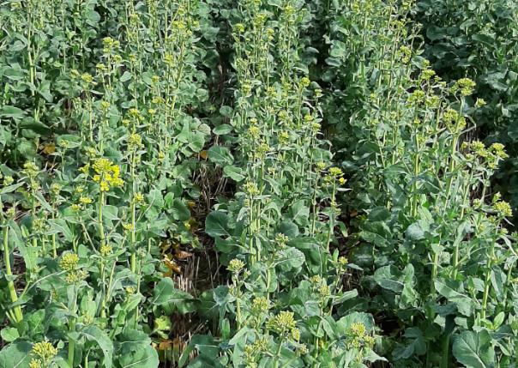

Score 6 (left), Score 2 (right)
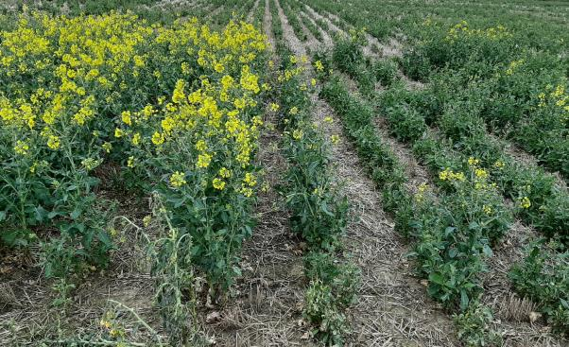

Score 3
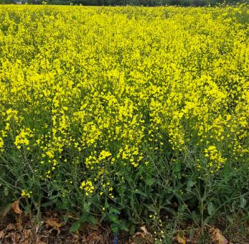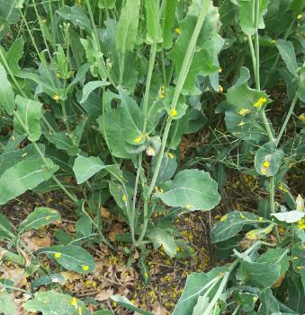

Score 2
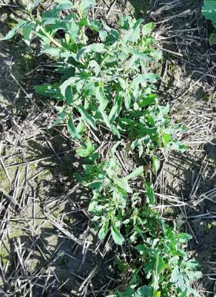

Score 1
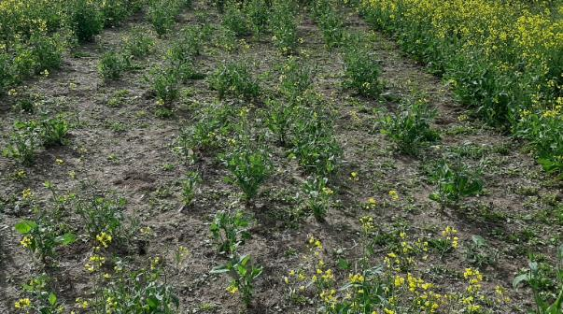

Completion of records
Data should be recorded in the Excel recording sheets within the trial workbooks.

Contact us
AHDB, Siskin Parkway East, Middlemarch Business Park, Coventry CV3 4PE

Email: info@ahdb.org.uk

